Python Api Challenge

1. The higher the latitude the lower the max temperature

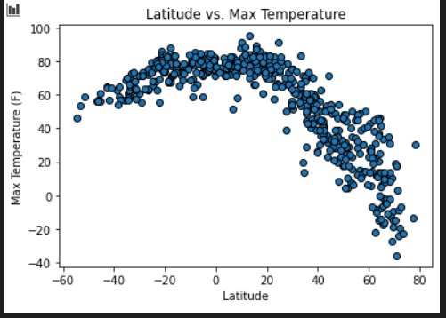

1. The closer you get to the equator, the max temp is closer to 100 F

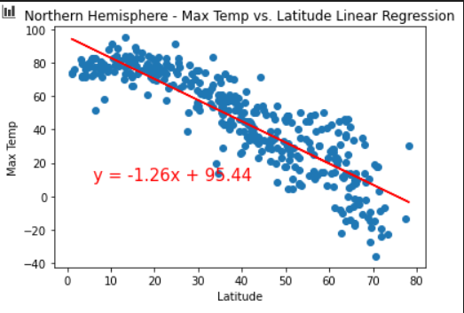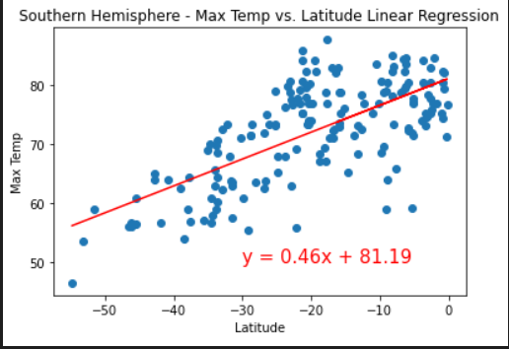

1. There is no direct correlation between latitude and humidity

